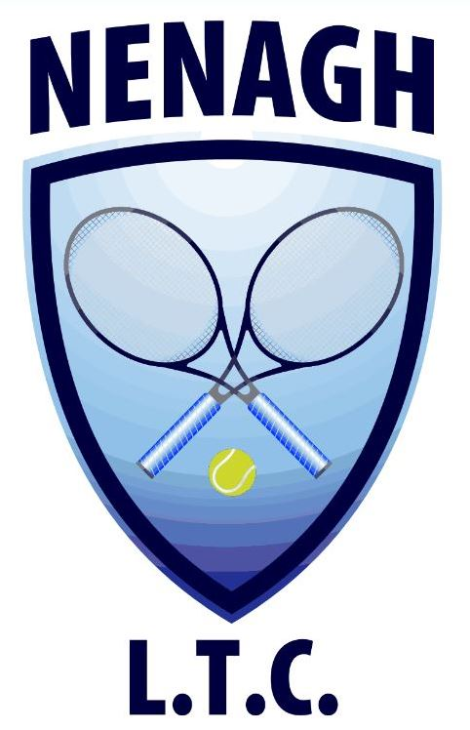Nenagh Lawn Tennis Club
Limerick Road, Nenagh, Co. Tipperary

067 – 33103
Senior Club Phone 087 9075656 Junior Phone – 085 2401591

www.nenaghltc.ie

2015 A.G.M

Present Officers

President:  Vice President: | Anne-Marie Darcy
Club Captain: | Frank O'Keefe*
Treasurer: | Áine McKenna*
Secretary: | George McGrath*

Present Committee

Tríona Dunne* |  | James Morris
Siobhán Dwan* |  | Ruth Murphy*
Kate Heduan |  | Lena O'Connor
David Kyne* |  | Mary Ryan
Ger McKenna* |  | Matty Ryan

Director of Tennis: Anne Fitzpatrick

All nominations will be posted on the notice board and on the website www.nenaghltc.ie 7 days prior to date of the AGM. Those officers/committee members marked with * have indicated their wish to resign. Officer/committee nominations for the coming year may be text to 087 9634583 or emailed to adarcy@tcd.ie and returned no later than Tuesday 27th of January 2015. Please ensure that the person you nominate is willing to run for the position. Nominations will not be accepted from the floor on the night of the AGM. In the interest of the club it is important that you attend the AGM and we look forward to seeing you on the night.

