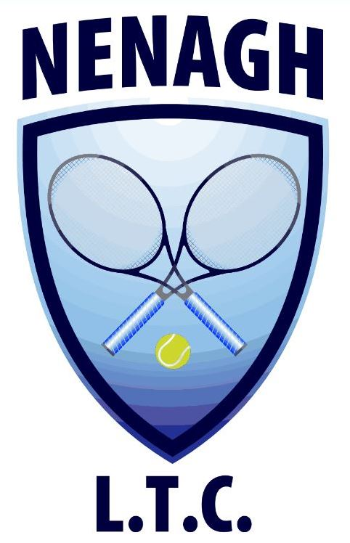Nenagh Lawn Tennis Club

Limerick Road, Nenagh, Co. Tipperary

067 – 33103
Senior Club Phone 087 9075656 Junior Phone – 085 2401591

www.nenaghltc.ie

2015 A.G.M

Club Members

The Annual General Meeting of Nenagh Lawn Tennis Club will take place in the Clubhouse on Wednesday February 4th at 8:00 pm.

In the interest of the Club it is important that you attend this meeting.

Thanking you,
NLTC Committee

