  About Frank  Frank is a fully qualified Level 1 and Level 2 Performance tennis coach. He is a fully licensed member of Tennis Coaches Ireland and is compliant with Garda Vetting procedures. Frank has represented Nenagh, Munster and Ireland at international level. He has vast experience in group coaching and has held successful camps for a number of years. |  |  | FRANK’S TENNIS PRESENTS  NENAGH LTC  JUNIOR TENNIS CAMP  JULY 4th – 8th  CAMP1 10am-12.00pm  CAMP2 1pm – 3pm  What’s it about !!!  This is a camp for kids aged 6-18. Lots of fun will be the order of each day. This is a perfect way for your child to meet new friends and learn to play a game for life !!!  - 3 Qualified Coaches  - Certificate of Completion  - Over 15 hours of Coaching  - Skills Development  - Daily Prizes  Contact Us  Phone: 0861932977  Email: frankokeeffe1@gmail.com  Web: www.tenniscoach.ie   Frank’s Tennis |  |  | 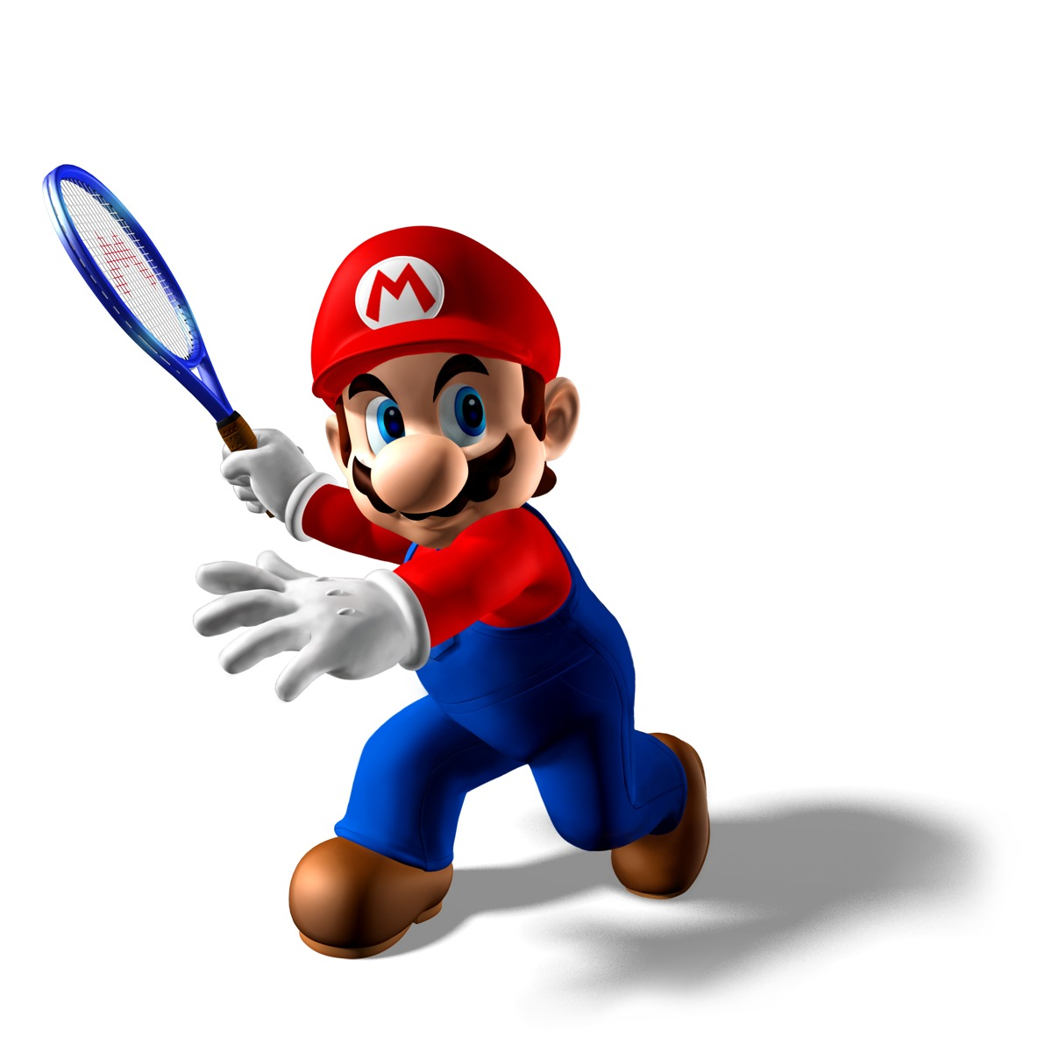  Frank’s Tennis

  Structure of Day  15 MINS Multi Skills Warm Up  45 MINS Tennis Skill Development  1 HOUR Competitive Tennis Play  What your child gets!!!  - 4 Qualified Coaches  - Daily Prizes  - 10 hours of Tennis  - FUN!!!! |  |  | For Parents  Registration at 9-10am Sat July 2nd  Children should bring plenty of snacks and lots of water. The children will be supervised during breaks and at the end of each camp to ensure safe departure from camp.  Please note: No child will be allowed to leave the club from arrival to departure at each camp unless prior notice is given by a parent/guardian.  COST  €50 per child for 5 days  TO BOOK  CHOOSE YOUR CAMP  CONTACT FRANK @ 0861932977 |  |  | 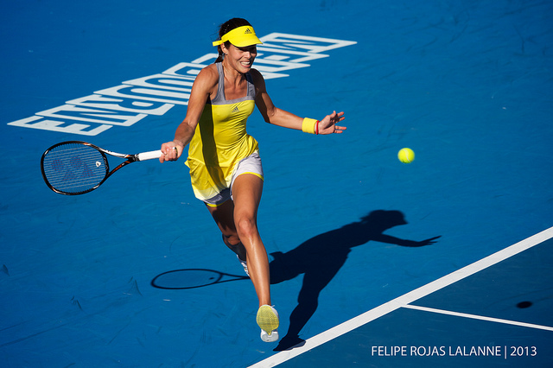  Frank employs only qualified coaches to work with him for his camps. All coaches are fully licensed with full Garda Vetting and have great experience working with children of all ages.  If you require any further information please do not hesitate to contact me.  ***MAX 30 children will be accepted in total per camp so to avoid disappointment please book early !!

